**Questions for Staff**

1. Are you satisfied with the existing timesheet process?

2. If NO please state why?

3. What are your expectations from this proposed web-based timesheet management system?

4. The homepage is displayed here which has a deadline date and three options to pursue further into the website. The deadline date will be automatically set and updated over time. Any suggestions to improve this?

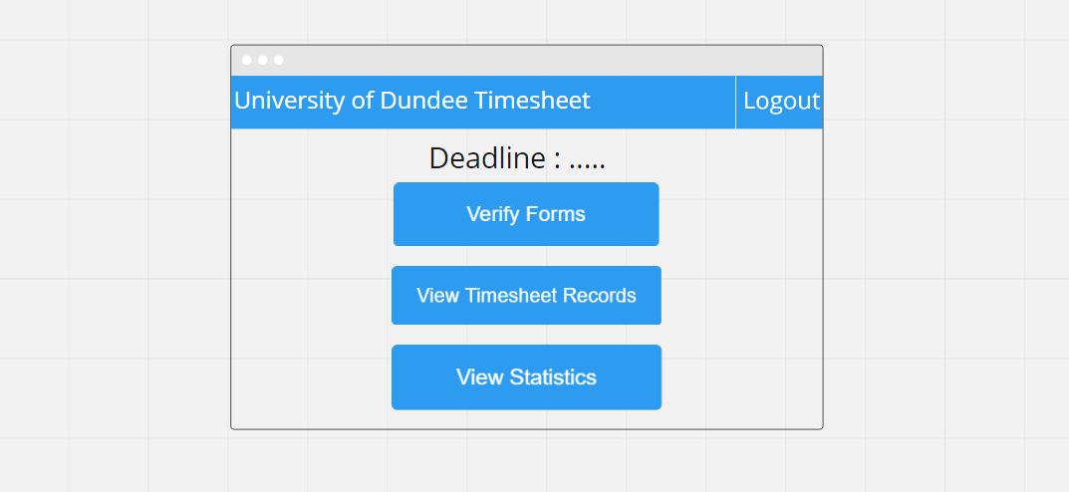

5. Here two options are designed to view timesheet records. In option 1 the complete records of all timesheets submitted by each student enrolled in the module will be displayed in the table without any filtering option in the page. While in option 2 the page will consist of filtering options using dropdown list for module, role and status which will retrieve the specific timesheet. The option 2 picture shows an example of filtering using status dropdown list. Please choose one of the options.

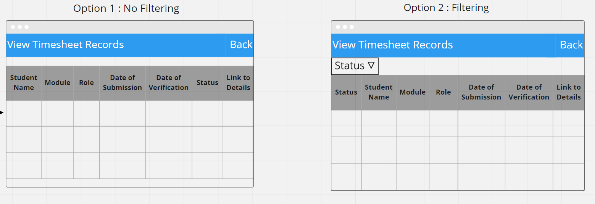

6. Justify your answer for the previous question.

7. State any additional ideas related to view timesheet records option.

8. Here two options are designed to view statistics. Both options will display the total number of hours worked in each week of the whole month in a bar chart. In option 1 there is no filtering option in the page. While in option 2 the page will consist of filtering options such as student name, module, role and timeline which will display the total number of hours worked for the specific options selected. Please choose one of the options.

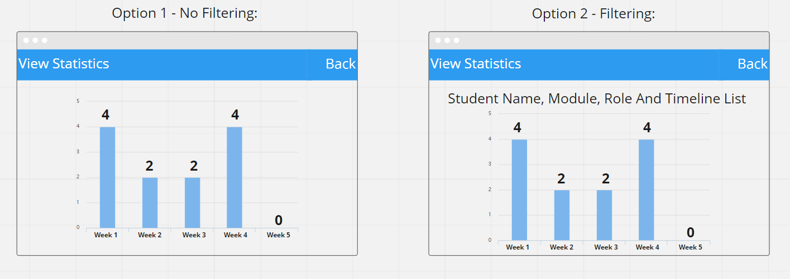

9. Justify your answer for the previous question.

10. State any additional ideas related to view statistics option.

11. The view forms page will display the complete records of all the timesheets submitted by each student. To view timesheet details the user can click the link of any records, which will load a page. This page will display the details of the student and the number of hours worked in the whole month. The page provides checkboxes for each week for approval from the lecturers. Apart from that, there is an option for the lecturer to suggest a pay rate for a student and can click the enter button. If the lecturer is satisfied then can click the approve button and if not satisfied can click the resubmit button. Any suggestions to improve this?

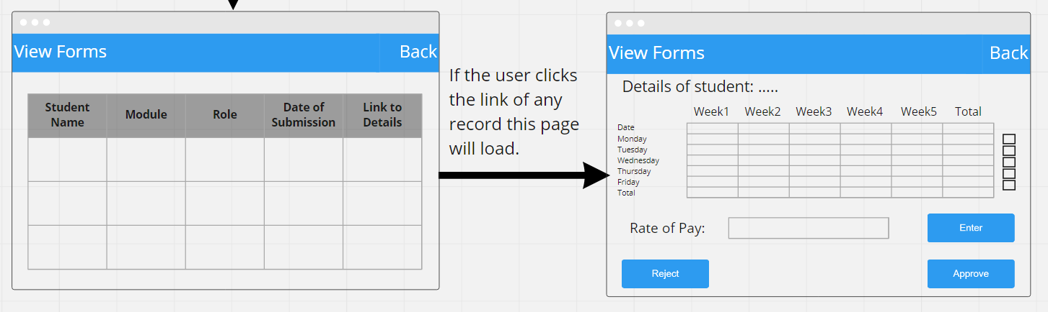

12. Do you want filtering options to display only specific records from all the timesheets submitted.

13. State any additional ideas related to verify forms option.